1. **About Department of MCA & M.Sc. IT**

**PARUL University**

Parul University is a legitimate university established under Gujarat Private University Act 2009, after legislation passed by the Government of Gujarat on 26th March 2015 giving University status to Parul Group of Institutes functioning under the aegis of Parul Arogya Seva Mandal Trust.

**Faculty of IT & Computer Science**

Faculty of IT and Computer Science, Parul University has materialized as one of the prime IT education providers at global level. Various departments under Faculty of IT and Computer Science strive in preparing IT-industry ready professionals by means of various skill development courses, vocational courses, co-curricular & extra-curricular activities, industry visits and expert lectures.

**MCA Department**

The Department of Master of Computer Application and Master of Science in Information Technology at Parul University emphasizes on building professionals in the domain of computer applications by providing necessary environment by means of facilitating suitable blend of technical and non-technical learning experience. The department cultivates students in various curricular, co-curricular and extra-curricular activities in order to produce future system analysts, system designers, and system programmers, application programmers, testing professionals, system managers, project managers, researchers and other leading positions in systems/IT department.

The departments offer various subjects from diversified technical/non-technical areas such as – core IT domain, management, communication skills, mathematics & logic building and rich pool of elective subjects.

The department of MCA and M.Sc. (IT) focuses on project-based learning, and hence students are motivated to work on tiny hands-on projects in practical oriented subjects to get better exposure. Moreover, throughout their MCA studies, students are required to work on around 3 mini/major projects in individual/team to get enough confidence on software-development and thereby become industry-ready.

1. **Project Profile** 
   1. **Project Definition**

The objective of the "Parul University E-Learning Platform" project is to create a comprehensive and user-friendly online learning platform tailored specifically for Parul University. This platform will facilitate remote education, improve access to educational resources, and enhance the overall learning experience for students, faculty, and staff.

* 1. **Project Descriptions**

The Parul University E-Learning Platform project is an ambitious initiative aimed at revolutionizing the educational experience for students, faculty, and staff at Parul University. In response to the growing demand for online education and the need for a more accessible and flexible learning environment, this project will develop a state-of-the-art e-learning platform using ASP.NET and Microsoft Visual Studio.

* 1. **Project Profile**

Hardware and Software Requirements:

Development Machine: Ensure that you have a capable development machine (laptop or desktop) with sufficient processing power, RAM, and storage to run Visual Studio and handle development tasks effectively.

Operating System: Microsoft Windows is recommended, as Visual Studio is primarily designed for Windows. Ensure that your OS is up to date.

Visual Studio: Install Microsoft Visual Studio, preferably the latest version available at the time of the project start. Visual Studio provides a comprehensive integrated development environment (IDE) for ASP.NET development…

* 1. **Problem Statement**

-Parul University currently lacks a centralized platform for delivering educational resources, resulting in limited access to course materials and learning resources for students and faculty.   
-As Parul University continues to grow, the existing infrastructure may struggle to support the increasing number of courses, students, and faculty members.

* 1. **Need for new system**

-As Parul University continues to grow and expand its course offerings, a scalable e-learning platform can efficiently handle the increasing number of courses, students, and faculty members.

Cost Savings:

-E-learning can reduce costs associated with traditional classroom-based education, such as physical infrastructure, printing, and commuting expenses. It can also optimize resource allocation.

* 1. **Project Profile**

The proposed e-learning system for Parul University should be a comprehensive and feature-rich platform that addresses the identified needs and challenges. Here are the key features and components that can be included in the system:  
1. User Authentication and Management:  
User registration and login with multi-factor authentication for security.  
User role management (students, instructors, administrators).  
User profile management with customizable profiles.  
2. Communication and Collaboration:  
Discussion forums for students and instructors.  
Private messaging and announcements for communication.  
Collaborative tools such as group projects and virtual classrooms.

* 1. **Scop**

Project Objective:

The primary objective of this project is to design, develop, and implement a modern and feature-rich e-learning platform tailored specifically for Parul University. The platform aims to enhance the educational experience for students, faculty, and staff by providing a flexible and accessible online learning environment.

Inclusions:

User Management:

User authentication and role-based access control.

User profiles and account management.

Course Management:

Creation, scheduling, and management of courses.

Support for various course types, departments, and faculties.

Content Delivery:

Upload and organization of course materials.

Support for diverse content formats and interactivity.

* 1. **Project Profile**

Enhanced Educational Experience: Students will benefit from an enriched learning experience with access to interactive content, multimedia resources, and collaborative tools, resulting in improved engagement and understanding of course materials. Flexible Learning Opportunities: The platform will provide students with the flexibility to learn at their own pace, accommodating diverse learning styles and schedules.

Efficient Course Management: Instructors will experience increased efficiency in course creation, content management, and assessment, allowing them to focus more on teaching and student interaction. Improved Communication and Collaboration: Enhanced communication tools, including discussion forums and messaging, will foster better collaboration between students and instructors, creating a more engaging learning community.

* 1. **Project Profile**

Microsoft Visual Studio building ASP.NET applications.

ASP.NET as the web application framework for building the platform's frontend.

Backend Technologies:

ASP.NET Web API: For building RESTful APIs to manage course content, user data, and other backend functionalities.

C# Programming Language: The primary language for server-side development in ASP.NET.

Entity Framework: For object-relational mapping and database interaction.

SQL Server or Another Database Management System: To store and manage application data securely.

Frontend Technologies:

HTML5, CSS3, JavaScript: For building responsive and interactive user interfaces.

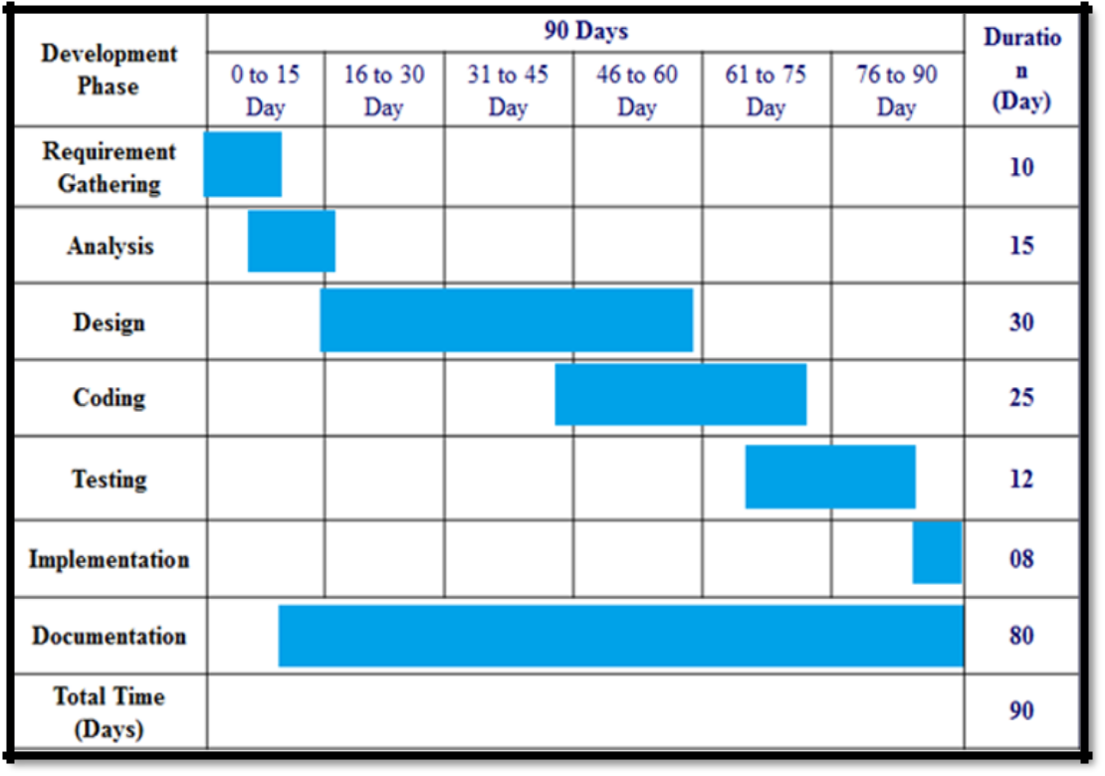

1. **Requirement Analysis**
   1. **Feasibility Studies**

Requirement Analysis and Feasibility Study are crucial phases in the development of the Parul University E-Learning Platform. These processes help identify project requirements, assess project viability, and ensure alignment with the university's objectives. Here's an overview of both phases:

Requirement Analysis:

1. Stakeholder Identification:

Identify key stakeholders, including students, faculty, administrators, and IT staff.

Conduct interviews, surveys, and workshops to gather input from stakeholders.

2. Gather Requirements:

Elicit and document detailed functional and non-functional requirements.

Define user stories, use cases, and system specifications.

Prioritize requirements based on importance and impact.

* + 1. **Technical Feasibility**

Assess the technical feasibility of building the e-learning platform.

Evaluate the availability of skilled developers, necessary tools, and technologies.

* + 1. **Economic Feasibility**

Estimate the project budget, including development costs, infrastructure, and ongoing maintenance.

Compare the budget with available resources and funding.

* + 1. **Operational Feasibility**

Evaluate how the platform will fit into the university's existing operations and processes.

Assess the readiness of faculty and staff to adopt the platform.

* + 1. **Social Feasibility**

The Car repair service provider or a Towing service provider demonstrates strong social feasibility through its potential to positively impact users and contribute to the creation of a supportive and inclusive automotive community.

One of the core aspects of social feasibility is the app's focus on mechanization and well-being. By providing users Towing service provider goals, the app encourages mechanics issues.

* 1. **Users of the system**

Students are the primary beneficiaries of the e-learning platform. They use the system to access course materials, participate in online classes, complete assignments, take quizzes and exams, track their progress, and collaborate with peers and instructors.

Administrative staff at Parul University have varying levels of access to the system. They manage user accounts, oversee course schedules, configure system settings, and ensure the platform's smooth operation. This group may include IT administrators, course coordinators, and system administrators.

And teachers.

* 1. **Modules**

User Management Module:

This module handles user registration, login, and profile management.

Features include user roles (student, instructor, admin), user authentication, and password management.

Course Management Module:

Instructors use this module to create, manage, and schedule courses.

Features include course creation, course enrollment, and scheduling tools.

Course Management Module:

Teachers use this module to create, manage, and schedule courses.

Features include course creation, course enrollment, and scheduling tools.

Administrative Dashboard Module:

Administrative staff use this module to manage users, courses, and system settings.

Features include user management tools, analytics, and reporting.

* 1. **Process Model**

Justification for selecting Agile Scrum:

Flexibility and Adaptability: Agile Scrum is designed to accommodate changing requirements and priorities, making it suitable for a project like the E-Learning Platform, where educational needs and technology may evolve over time.

Stakeholder Collaboration: Scrum encourages frequent collaboration between the development team and stakeholders, which is essential for gathering feedback, clarifying requirements, and ensuring that the platform aligns with Parul University's educational goals.

Iterative and Incremental Development: Scrum divides the project into iterations (sprints) where small, working increments of the software are delivered at the end of each sprint. This approach allows for early testing and feedback, mitigating risks associated with late-stage changes.

Transparency and Visibility: Scrum provides transparency into project progress through daily stand-up meetings, sprint reviews, and sprint retrospectives. This transparency helps identify and address issues promptly.

Empowered Teams: Scrum empowers cross-functional teams to make decisions, self-organize, and take ownership of the project's success. This approach fosters innovation and accountability among team members.

Risk Mitigation: Scrum's frequent inspection and adaptation cycles enable the team to identify and address risks early in the project, reducing the likelihood of major setbacks.

Product Backlog

|

v

Sprint Planning

|

v

Sprint Development

|

v

Sprint Review

|

v

Sprint Retrospective

|

v

Repeat

Product Backlog:

The project starts with the creation of a product backlog, a prioritized list of features, user stories, and requirements.

Sprint Planning:

During sprint planning, the development team selects a set of high-priority items from the product backlog to work on in the upcoming sprint.

The team also defines the sprint goal and creates a sprint backlog, a detailed plan for the sprint.

Sprint Development (1-4 weeks):

The development team works on implementing the selected backlog items.

Daily stand-up meetings are held to discuss progress, challenges, and plan the day's work.

Sprint Review:

At the end of each sprint, a sprint review meeting is conducted to showcase the completed work to stakeholders.

Feedback is gathered, and adjustments are made to the product backlog.

Sprint Retrospective:

The team holds a retrospective meeting to reflect on the sprint's performance and identify areas for improvement in their processes.

Repeat:

The process repeats with the selection of a new set of backlog items for the next sprint.

* 1. **Hardware and software requirement**

Hardware Requirements:

Server Infrastructure:

Multiple web servers and application servers to handle user requests and application logic.

Sufficient CPU, RAM, and storage resources to accommodate anticipated user loads and growth.

Load balancers for distributing traffic and ensuring high availability.

Database Servers:

One or more database servers (SQL Server, MySQL) to store user data, course content, and system configurations.

Adequate storage capacity and optimized database performance.

* 1. **Use cases**

|  |  |
| --- | --- |
| **Actors** | **Actions** |
| admin | * Login: user can login * Manage User Accounts: Administrators can create, modify, or deactivate user accounts. * Course Management: Administrators can add, modify, or remove courses. * Manage Instructors: Administrators can add, modify, or remove instructor accounts. * Student Enrollment: Administrators can assist with student enrollment and registration. * Generate Reports: Administrators can generate reports on student data, course statistics. * System Maintenance: Administrators can ensure the system is running smoothly and perform updates. |
| teacher | * Login: user can login * Create Courses: Instructors can create and manage course content. * Grade Assignments: Instructors can grade assignments, quizzes, and exams. * Communicate with Students: Instructors can send announcements and messages. * Schedule Office Hours: Instructors can schedule and manage virtual office hours. * Access Analytics: Instructors can view student engagement and progress data. * Access Resources: Instructors can upload and manage course materials. |
| Student | * Login: user can login * View Courses: Students can browse and view the list of available courses. * View Grades: Students can check their grades and academic performance. * Submit Assignments: Students can submit assignments and projects online. * View Calendar: Students can access an academic calendar for important dates. * Access Resources: Students can access course materials, textbooks, and resources. * Interact with Instructors: Students can communicate with instructors through messaging or forums. |
| visitor | Visit Programs: visitor can visit programs |

* 1. **Use case Diagram**

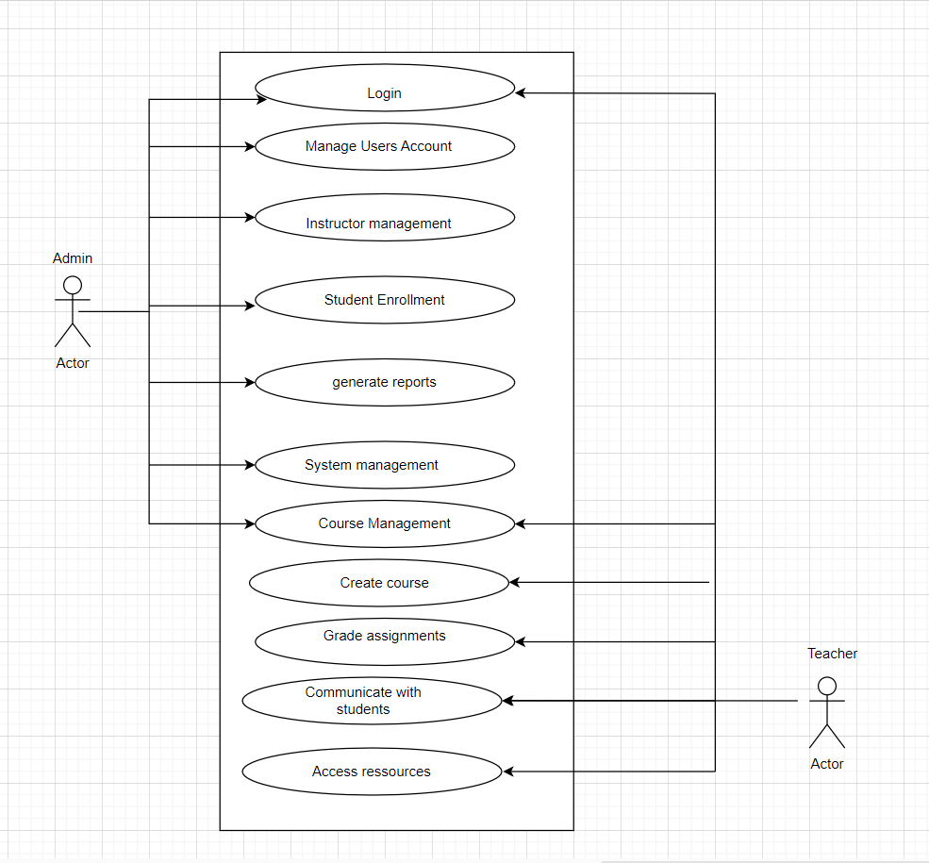

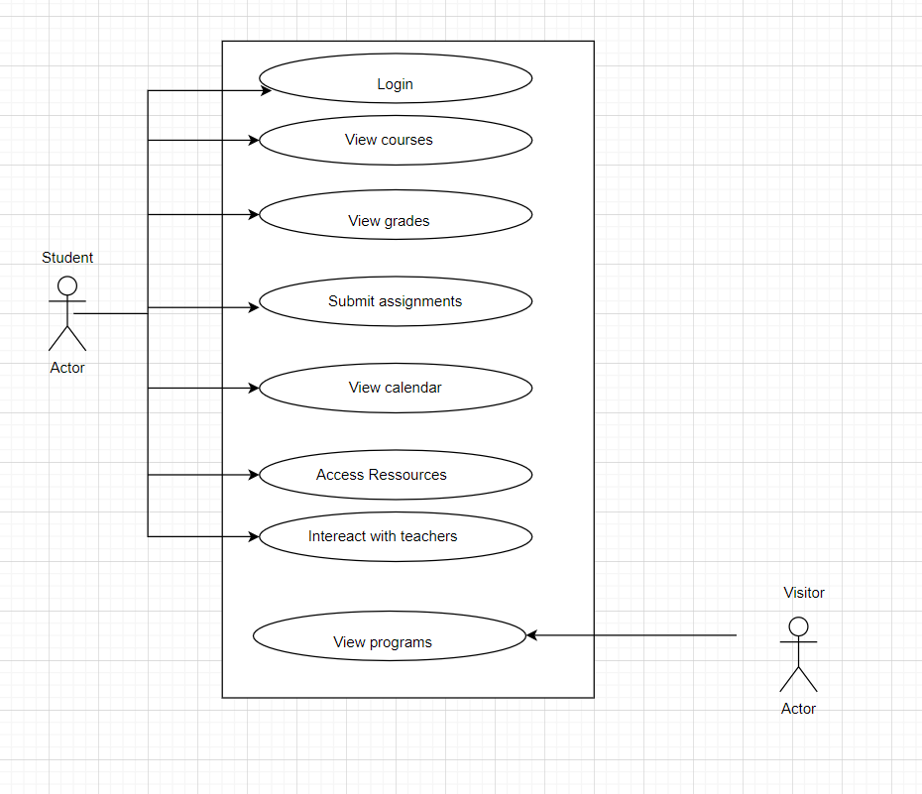

Use case diagram

1. **Design**
   1. **Use case scenario**

|  |  |
| --- | --- |
| Use case scenario | Use case ID:UC:01 |
| Use case name | User registration |
| Actors | A new user wants to register on the eLearning website to access online courses. |
| Preconditions | New user student |
| Main Flow | NaN |
| Description | User registration |

|  |  |
| --- | --- |
| Use case scenario | Use case ID:UC:01 |
| Use case name | User registration |
| Actors | A new user wants to register on the eLearning website to access online courses. |
| Preconditions | New user student |
| Main Flow | NaN |
| Description | User registration |

Postconditions User has a registered account and is logged in.

Exceptions: 1. If the email is already registered, the system displays an error message.

2. If the registration information is incomplete or invalid, the system displays an error message.

|  |  |
| --- | --- |
| Use case scenario | Use case ID: UC:02 |
| Use case name | User Login |
| Description | A registered user wants to login in their account to access online courses. |
| Preconditions | User has a registered account |
| Main Flow | User navigates to the eLearning website |
| Actors | User registered (Student) |

Postconditions User is logged in and can access their courses and materials.  
Exceptions If the login credentials are incorrect, the system displays an error message.

|  |  |
| --- | --- |
| Use case scenario | Use case ID: UC:03 |
| Use case name | Browse courses |
| Description | A user, whether registered or not, wants to browse the available courses on the website |
| Preconditions | NaN |
| Main Flow | User navigates to the eLearning website |
| Actors | User (Registered or Guest) |

* 1. **Diagram**
     1. **UML**

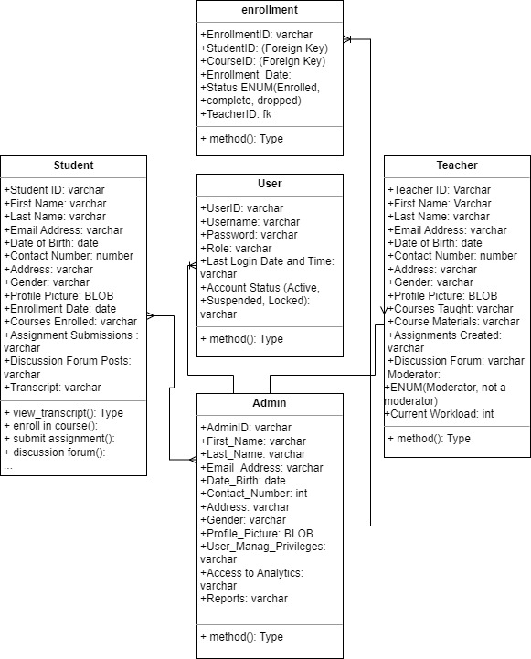

UML Diagram

* + 1. **ER Diagram**

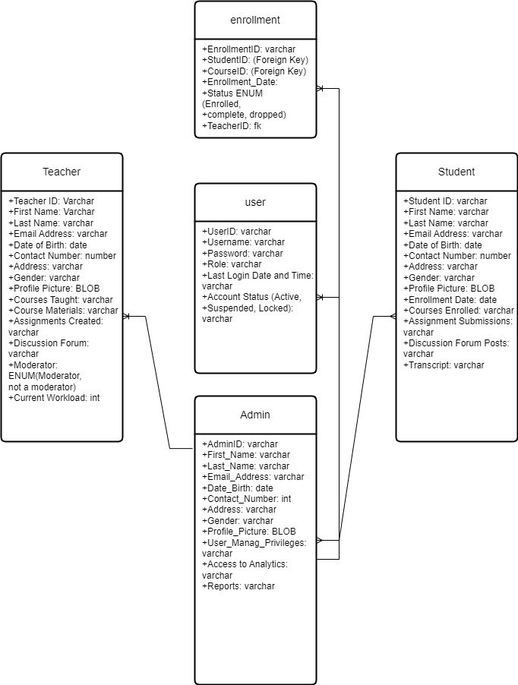

ER Diagram

* 1. **Data dictionary**

|  |  |  |  |  |  |
| --- | --- | --- | --- | --- | --- |
| Admin | Data type | Primary key | Foreign key | Unique key | Description |
| AdminID | Int/Varchar | Yes | No | Yes | Unique Identifier |
| UserName | Varchar (50) | No | No | Yes | Admin simple name in one word |
| Password | Varchar (50) | No | No | No | Password |
| Email | Varchar (50) | No | No | Yes | Mail |
| Name | Varchar (100) | No | No | No | Full name |

|  |  |  |  |  |  |
| --- | --- | --- | --- | --- | --- |
| Teacher | Data type | Primary key | Foreign key | Unique key | Description |
| TeacherID | Int/varchar | Yes | No | Yes | Unique Identifier |
| UserName | Varchar (50) | No | No | Yes | Teacher name in one word |
| Password | Varchar (50) | No | No | No | Password |
| Email | Varchar (50) | No | No | Yes | Mail |
| Name | Varchar (100) | No | No | No | Full name |

|  |  |  |  |  |  |
| --- | --- | --- | --- | --- | --- |
| Student | Data type | Primary key | Foreign key | Unique key | Description |
| StudentID | Int/varchar | Yes | No | Yes | Unique Identifier |
| UserName | Varchar (50) | No | No | Yes | Student name in one word |
| Password | Varchar (50) | No | No | No | Password |
| Email | Varchar (50) | No | No | Yes | Mail |
| Name | Varchar (100) | No | No | No | Full name |

|  |  |  |  |  |  |
| --- | --- | --- | --- | --- | --- |
| Course | Data type | Primary key | Foreign key | Unique key | Description |
| CourseID | Int/varchar | Yes | No | Yes | Unique Identifier |
| CourseName | Varchar (100) | No | No | No | course name |
| Description | Varchar (50) | No | No | Yes | Mail |
| InstructorID | Varchar (100) | No | No | No | Foreign Key |

|  |  |  |  |  |  |
| --- | --- | --- | --- | --- | --- |
| Instructor | Data type | Primary key | Foreign key | Unique key | Description |
| InstructorID | Int/varchar | Yes | No | Yes | Unique Identifier |
| CoursName | Varchar (50) | No | No | No | Course name |
| Email | Varchar (50) | No | No | Yes | Mail |

|  |  |  |  |  |  |
| --- | --- | --- | --- | --- | --- |
| Program | Data type | Primary key | Foreign key | Unique key | Description |
| ProgramID | Int/varchar | Yes | No | Yes | Unique Identifier |
| ProgramName | Varchar (100) | No | No | No | Program name |
| Description | Text | No | No | Yes | Description of the program |

|  |  |  |  |  |  |
| --- | --- | --- | --- | --- | --- |
| Enrollment | Data type | Primary key | Foreign key | Unique key | Description |
| EnrollmentID | Int/varchar | Yes | No | Yes | Unique Identifier |
| StudentID | Varchar (100) | No | No | No | Foreign Key |
| CourseID | Varchar (50) | No | No | Yes | Foreign key |

1. **Implementation**
   1. **Form layout**

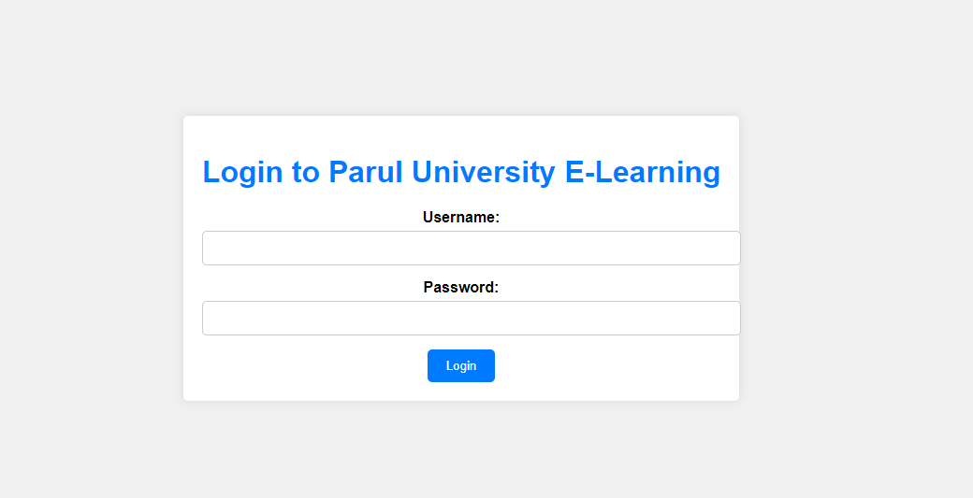

Login page

* 1. **Report Layout**

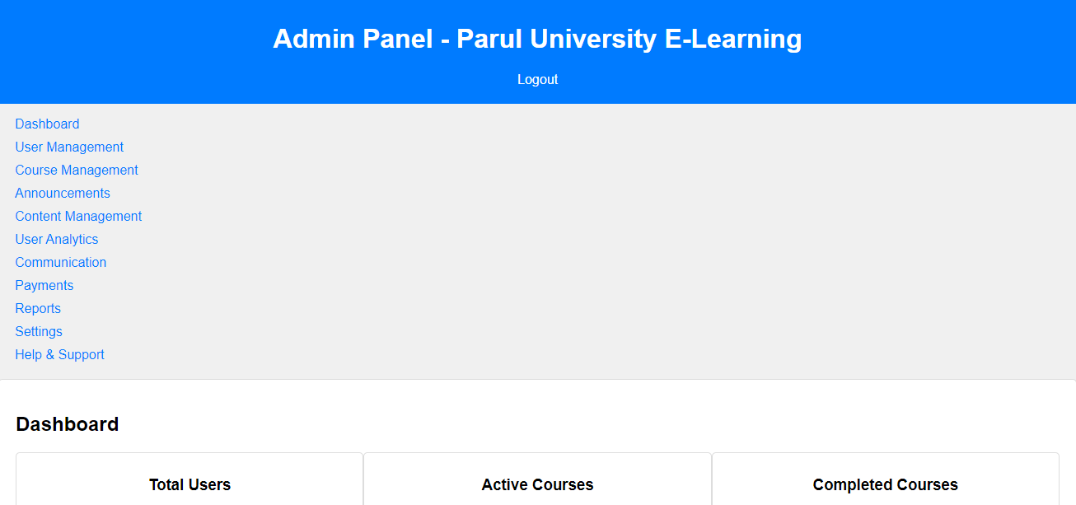

This is Admin page

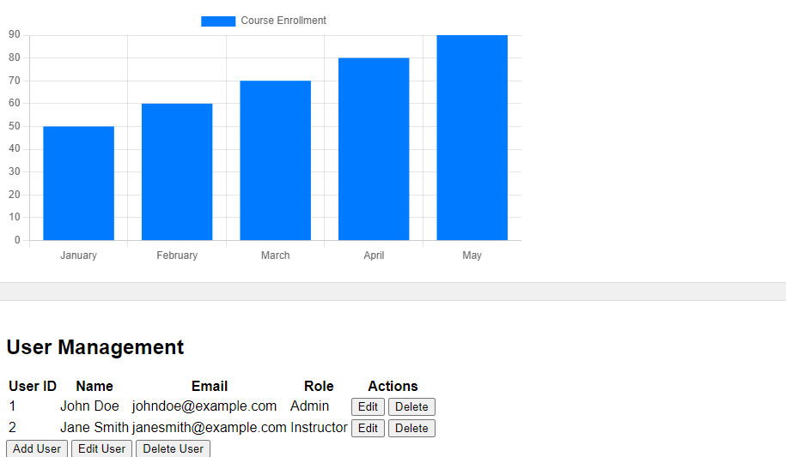

This is user management dashboard from admin page

* 1. **Coding Convention (Business Logic)**

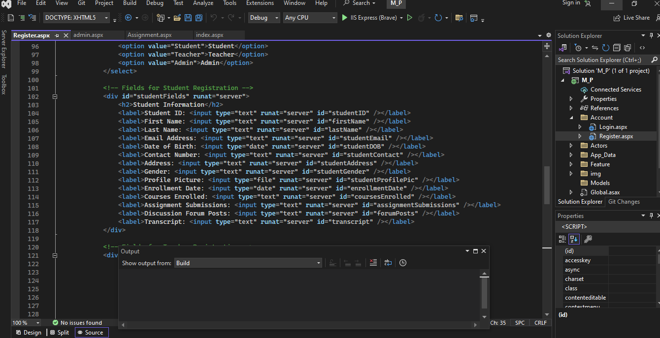

Coding Convention of the register page

1. **Testing**
   1. **Test Strategy**

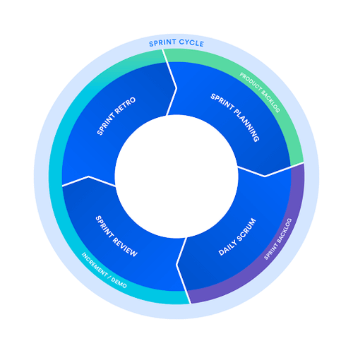

* 1. **Test Cases**

User Registration:

Verify that users can successfully register with valid information for all roles (Student, Teacher, Admin).

Ensure that registration fails with appropriate error messages for invalid or missing information.

Test the handling of duplicate email addresses during registration.

User Login:

Test successful login with valid credentials.

Verify that login fails with appropriate error messages for incorrect credentials.

Test the "Forgot Password" functionality for password reset.

User Roles and Permissions:

Ensure that users have the correct permissions based on their roles (e.g., students can access course materials, teachers can create assignments).

Verify that administrators have access to user management and analytics features.

Course Management:

Test the creation of new courses by teachers or administrators.

Verify that students can enroll in courses successfully.

Ensure that courses are accessible only to authorized users.

Assignment Submission:

Test the submission of assignments by students.

Verify that assignments are correctly associated with courses and students.

Check for deadlines and late submissions.

Discussion Forum:

Test the creation of discussion topics and posts.

Verify that discussions are categorized by courses.

Ensure that moderators can manage discussions appropriately.

Grading and Assessment:

Test the grading process for assignments and exams.

Verify that grades are correctly recorded and displayed to students.

Ensure that students can view their transcripts.

Notifications and Alerts:

Test the system's ability to send notifications to users (e.g., event announcements, assignment reminders).

Verify that users receive notifications through various channels (e.g., email, in-app alerts).

1. **Future Enhancement**

Mobile App: Develop a dedicated mobile application for students and teachers, allowing them to access course materials, assignments, and discussions on the go.

Advanced Analytics: Enhance the analytics module to provide deeper insights into student performance, engagement, and course effectiveness. Implement predictive analytics to identify at-risk students.

Gamification: Introduce gamification elements to make learning more engaging. Use badges, leaderboards, and rewards to motivate students to actively participate in courses.

AI-Powered Chatbots: Implement AI-powered chatbots to provide instant support to users. Chatbots can answer common questions, assist with navigation, and offer personalized recommendations.

Virtual Labs: Create virtual labs for science and engineering courses, allowing students to perform experiments and simulations online.

Integration with Learning Management Systems (LMS): Enable integration with popular LMS platforms to streamline content creation and management for teachers and provide a seamless experience for students.

Video Conferencing Integration: Integrate video conferencing tools for live lectures, webinars, and virtual classrooms. Ensure seamless communication between teachers and students.

1. **Biography**

Step-by-step ASP.NET MVC Tutorial for Beginners | Mosh: <https://youtu.be/E7Voso411Vs?si=D0rZtxvQxv_0CM2x>

ASP.NET documentation <https://learn.microsoft.com/en-us/aspnet/core/?view=aspnetcore-7.0>

ASP.NET Core Documentation <https://jakeydocs.readthedocs.io/en/latest/>

AspNetCore.Docs <https://github.com/dotnet/AspNetCore.Docs>

ASP.NET Core <https://www.typescriptlang.org/docs/handbook/asp-net-core.html>

CSS Reference <https://www.w3schools.com/cssref/index.php>

HTML: HyperText Markup Language <https://developer.mozilla.org/en-US/docs/Web/HTML>

Add your project to GitHub:

git init

git add.

git commit -m "Initial commit"

git remote add origin <https://github.com/yourusername/your-repo.git>

git push -u origin master